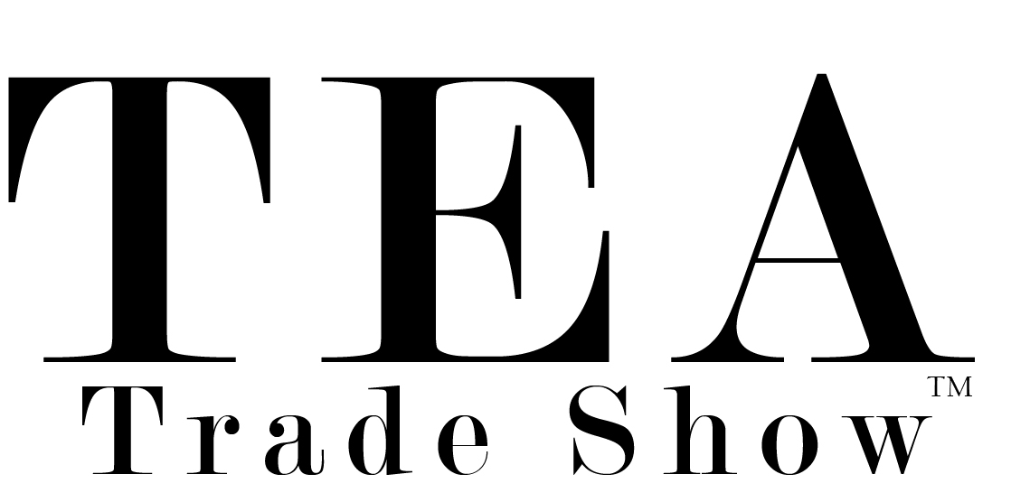
EXHIBITOR REGISTRATION FORM/RECEIPT
Please complete this form and submit by email to info@theteahousetimes.com or by mail to Tea Trade Show, c/o The Tea House Times, LLC, 2 Main Street #1049, Sparta, NJ 07871 USA If you have any questions, please
contact us via email or phone +1-973-551-9161
Step 1: Contact Information
Step
TEA Trade Show™ (TTS) is a production of The Tea House Times, LLC
It is a B to B show. Business-to-Business only and is not open to consumers, hobbyists, media, or anyone seeking to make individual purchases. TEA Trade Show™ is dedicated to showcasing wholesale products and services surrounding the tea industry including tea, accessories, accoutrements, food, gifts, dinnerware, and more. Exhibitors may register using this form. Only pre-approved, registered buyers and exhibitors may access the “show floor”. & Booth Selections
Contact name: | Contact email:
Contact phone: | Contact cell phone:
COMPANY NAME
COMPANY ADDRESS:
COMPANY PHONE:
BUSINESS TYPE:
PRODUCTS/SERVICES:
YOUR EXHIBITION SPACE FEE INCLUDES THE LISTED BENEFITS ASSIGNED TO YOUR PARTICULAR CATEGORY AS OUTLINED ON TEATRADESHOW.COM – LINK to Info. Choose below.
EXHIBITOR $1800 | EXHIBIT/SPONSOR $2800 | EXHIBIT/PARTNER $3500 | EXHIBIT/LEADER $5500
COUNTRY OF ORIGIN $3200 (all COO member businesses receive 25% discount on above exhibit options)
AMOUNT DUE: USD $
EXHIBIT SPACE CONTENT: Products or services of interest to the tea industry may be “exhibited” but must be a direct service of, manufactured by, or exclusively for distribution by the exhibitor. All products and services shall bear the brand or trademark of exhibitor. Tea Trade Show reserves the right to require removal of inappropriate materials or exclude or remove an exhibitor for non-compliance of any regulations, guidelines, requests.
Payment Terms: Payment in full and paid once yearly to continue.
Payment Methods
Check (payable to The Tea House Times, LLC, 2 Main Street #1049, Sparta, NJ 07871)
Credit Card: #: Exp. date: CVV Code:
Name as it Appears on Card:
Street Address for Card:
I have read, understand and agree to the terms of the TeaTradeShow.com policies and procedures and payment terms and hereby authorize 100% of fee to be charged upon receipt.

Signature: | Date:

BOOTH MATERIALS: Please submit all of your virtual booth listing information, images and other materials applicable to your exhibition package to info@theteahousetimes.com Use subject line: TTS + Company Name

